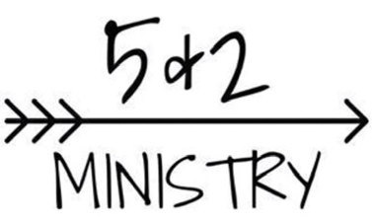

Purchasing $20 Tickets

Your original purchase of a $20 ticket will get you into the raffle, food and beverage.
When inside, you purchase additional tickets for $1 each to participate in the raffle rounds. Side raffles are $5 a ticket and the silent auction ticket cost to be announced.

Raffle Rounds

HOW IT WORKS: Each round will have 5 minutes for buying and collecting tickets in buckets. Winner must be present and track ticket numbers to claim prizes. Some rounds will have multiple items to choose from, first drawn ticket picks first item. Tickets are $1 each and can be used in any round.
EXAMPLE:

Round No. | Round Prize | Round Sponsor
1 | Stuffed Pork Chops - Neckers Company – 4 Winners
2 | Assorted Cheese – Donated by Cabhi Farms – 3 Winners
3 | T-Bone Steak - Neckers Company - 4 Winners
4 | Bucket of Wings - Donated by Local Wing Stops – 9 Winners
5 | Pork Loin - Neckers Company - 4 Winners
6 | Delmonico Steak - Neckers Company – 4 Winners
7 | Prime Rib - Neckers Company - 3 Winners
8 | Homemade Pie - Meeder's Restaurant - 10 Winners
9 | NY Strip Steak - Neckers Company - 4 Winners
10 | Bacon (4lbs) - Neckers Company - 5 Winners

Side Raffles
HOW IT WORKS: $5 per ticket. Tickets will be drawn after Round 13. Tickets can be placed in any of the following raffles:

Silent Auction – Items to be announced

